Heavy Weight # 7

**Series #1 w/o strip; Series #2 w/ strip**

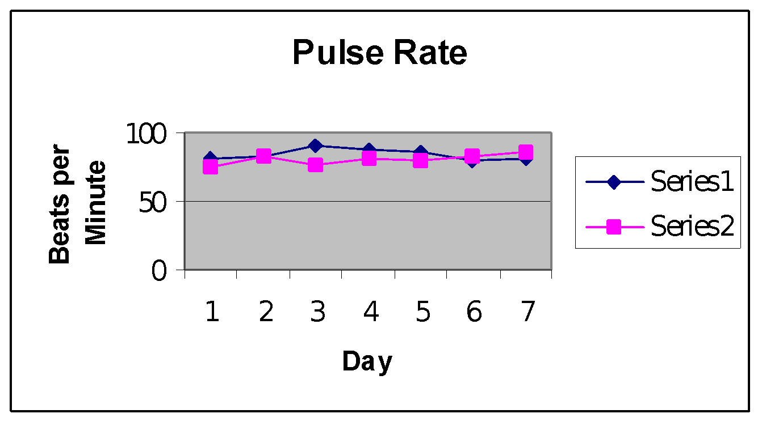

Series #1 mean: 84.0096 bpm; Series #2 mean: 80.351 bpm

The Series #2 mean has a .00129 probability of occurring by chance when compared to the Series #1 mean. This gives strong evidence that the nasal strip decreased the subject’s pulse rate.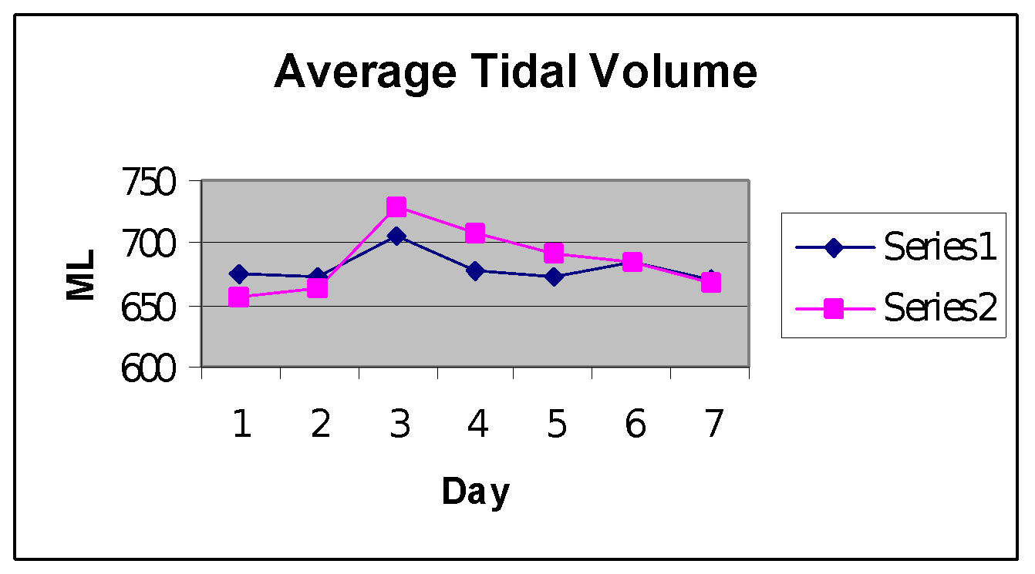

Series #1 mean 679.3324 ml; Series #2 mean: 668.048

The Series #2 mean has a .076 probability of occurring by chance when compared to the Series #1 mean. This gives strong evidence that the nasal strip increased the subject’s tidal volume.